Architecture ontology: An ontology describing how to build houses that stay cool in the summer, warm in the winter, and filled with natural light during the day.

*Department of computer science and Information Technology, University of Sargodha.*

***Editor:*** Hajra Anwar, Umaima, Gul la lae, Madiha.

**Abstract:**

Our ontology aims to improve understanding of home architecture by incorporating detailed recommendations tailored to different climate types. We expand upon the Weather Condition class and its subclasses to include specific elements such as window placement, ventilation systems, and building materials. By categorizing homes according to climate conditions, we provide practical guidance for optimizing window placement, selecting appropriate ventilation systems, and choosing suitable building materials to enhance comfort and energy efficiency.

**Keywords:** Ontology, Architecture, Climate.

Recognizing the intricate relationship between climate and architecture, this ontology seeks to provide a comprehensive framework for understanding and optimizing home design based on regional climate conditions. By expanding upon existing ontological structures and integrating specific recommendations for window placement, ventilation systems, and building materials, this ontology aims to offer valuable insights for architects, urban planners, builders, and homeowners alike. The foundation of this ontology lies in the Weather Condition class and its subclasses, which serve as the cornerstone for categorizing different climate types. Furthermore, the choice of building materials profoundly influences a home's performance and sustainability. Informed by climate-specific considerations, such as durability, insulation properties, and environmental impact, the ontology offers guidance on selecting appropriate materials for different climate zones.

**Ontology Requirements:**

*a. Non-Functional Requirements:*

Make sure all the advice is easy to understand and can be used for different types of homes, no matter where they're located.

- Keep it simple and straightforward so anyone, even if they're not experts, can use it to improve their home.

*b. Functional Requirements:*

Groups of Competency Questions:

- Group 1: Window Placement and Building Orientation:

Answer questions like "Where should I put windows to let in the most breeze?" and "Which way should my house face to catch the wind?"

-Group 2: Solar Exposure and Daylighting:

Help with questions such as "How can I make sure my house gets enough sunlight without getting too hot?" and "What's the best way to use sunlight to light up my home during the day?"

**Methodology**:

Research and Gathering: Collect information on climate, architecture, and building materials.

Design and integration: Create a structured ontology with climate zones, window placement, ventilation, and materials.

*Classes:*

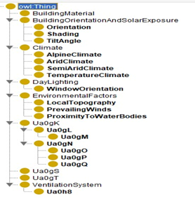

Fig1: Classes of ontology

*Data property:*

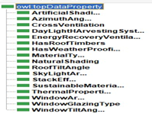

Fig2: Data property of ontology.

*Object property:*

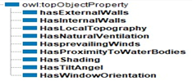

Fig2: Object properties of ontology.

Testing and updating: Evaluate usability, gather feedback, and continuously refine the ontology for accuracy and relevance.

Reusability:

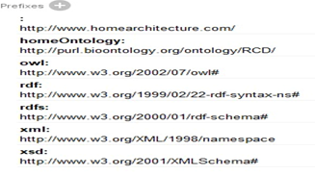Fig4: Imported classes

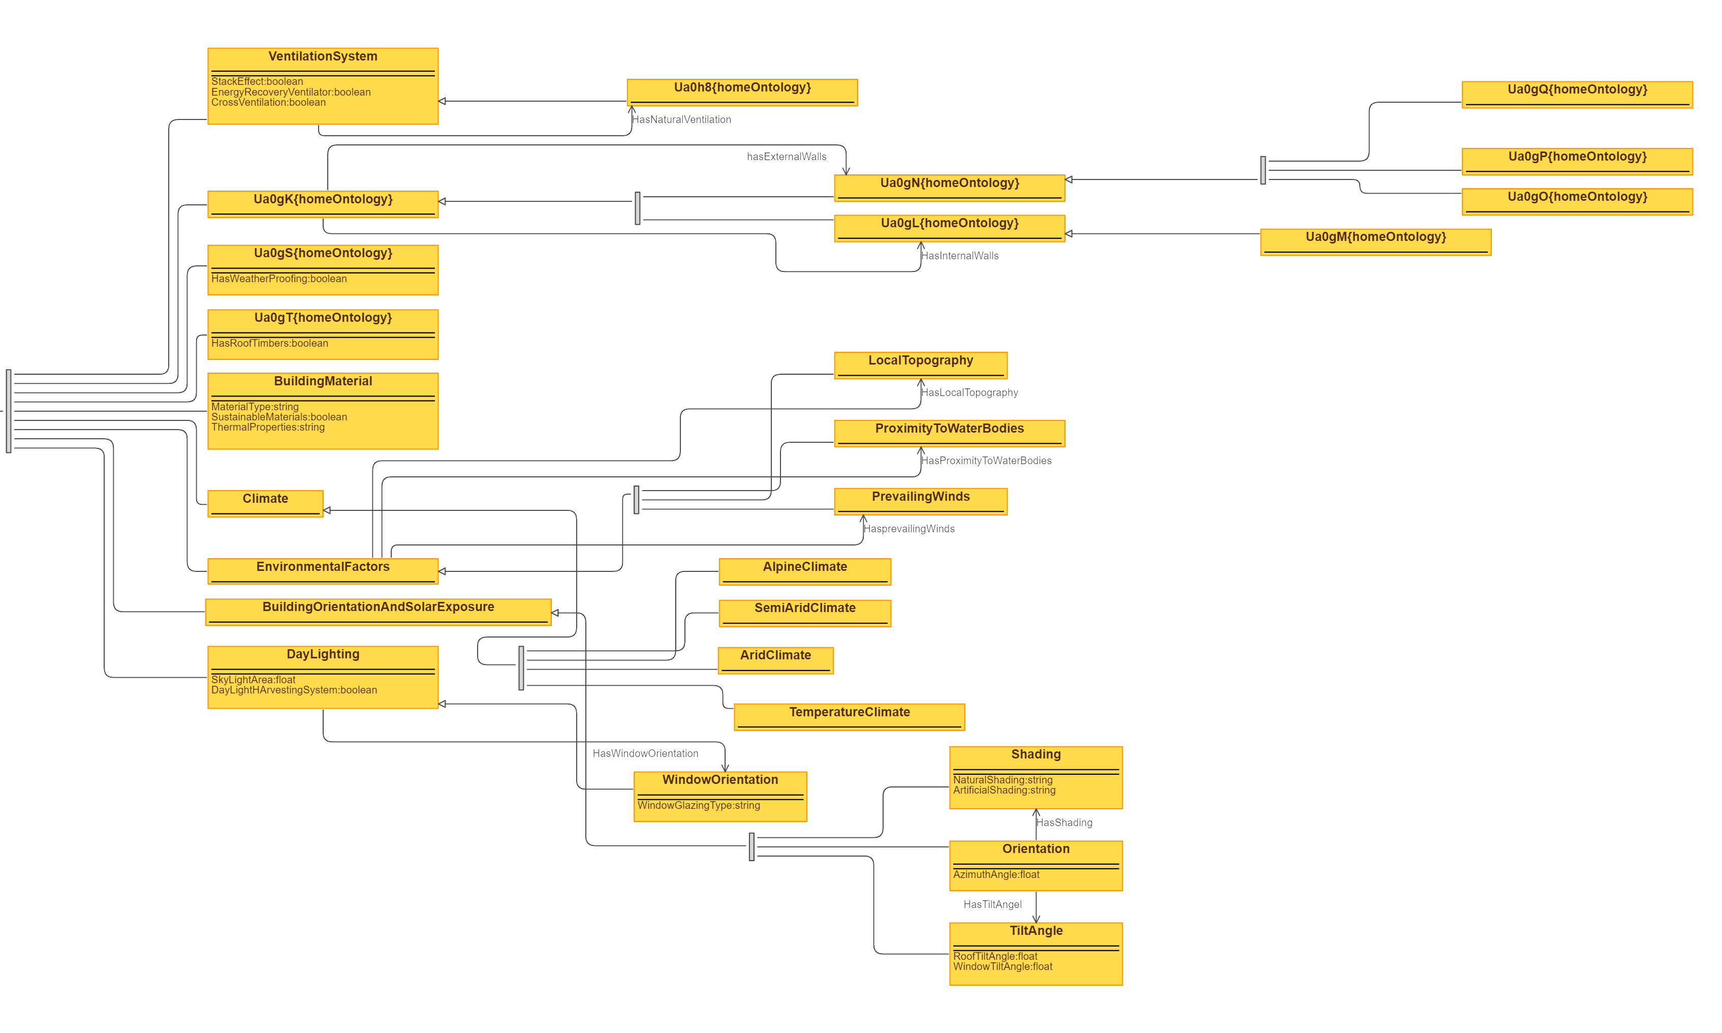

Fig5: Home Architecture ontology visualized

**SPARQL Queries:**

**Query 1: Retrieve Prevailing Winds for a Given Environmental Factor**

PREFIX ex: <http://www.homearchitecture.com >

SELECT ?environmentalFactor ?prevailingWind

WHERE { ?environmentalFactor ex:hasPrevailingWinds ?prevailingWind .

}

**Query 5: List Buildings with Natural Ventilation**

PREFIX ex: < http://www.homearchitecture.com >

SELECT ?building

WHERE {

?building ex:hasNaturalVentilation ex:NaturalVentilation .

}

**Query 3: Get Orientation and Tilt Angle of a Building**

PREFIX ex: < http://www.homearchitecture.com >

SELECT ?building ?orientation ?tiltAngle

WHERE {

?building ex:hasOrientation ?orientation .

?orientation ex:hasTiltAngle ?tiltAngle .

}

**Query 4: Fetch Window Area and Glazing Type for Daylighting**

PREFIX ex: < http://www.homearchitecture.com >

SELECT ?daylighting ?windowArea ?glazingType

WHERE {

?daylighting ex:windowArea ?windowArea .

?daylighting ex:windowGlazingType ?glazingType .

}

**Query 5: Identify Sustainable Building Materials**

PREFIX ex: < http://www.homearchitecture.com >

SELECT ?material

WHERE {

?material ex:sustainableMaterials true .

}

**Pitfall Scanning:**

Uploaded the file on GitHub and pasted the link on Ontology pitfall scanner:

<https://oops.linkeddata.es/>

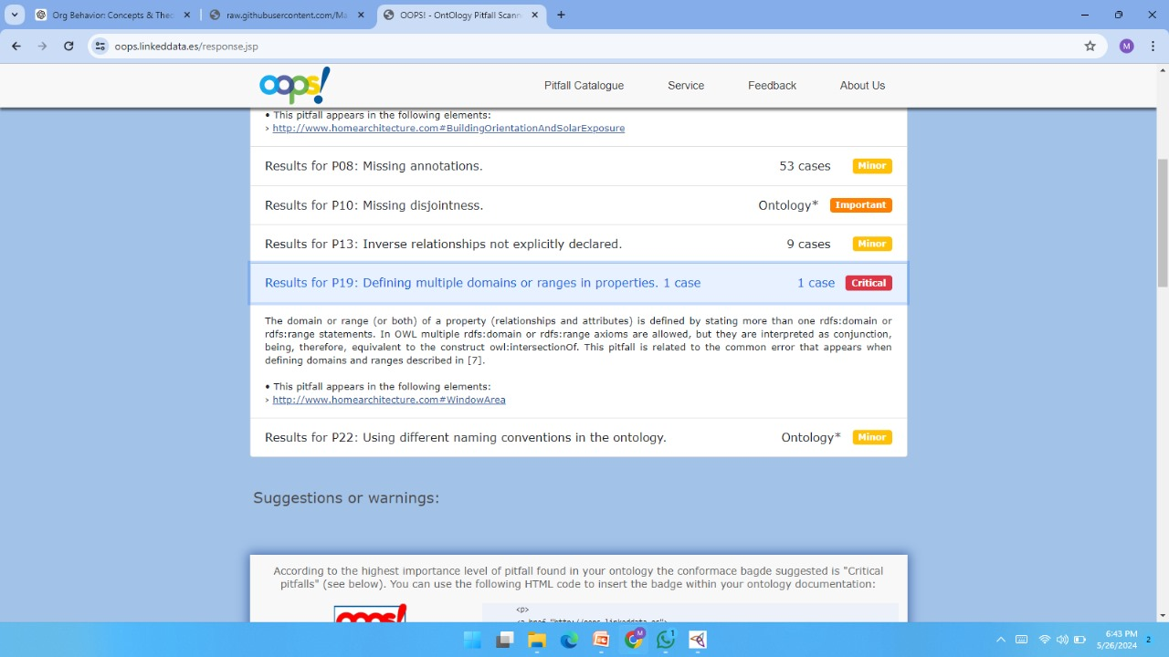

**P19: Defining multiple domains or ranges in properties**  
Solution: Checked the window area class and removed one domain that was added mistakenly.   
  
**P10: Missing Disjointness**  
Solution: Added the disjoint in sub classes

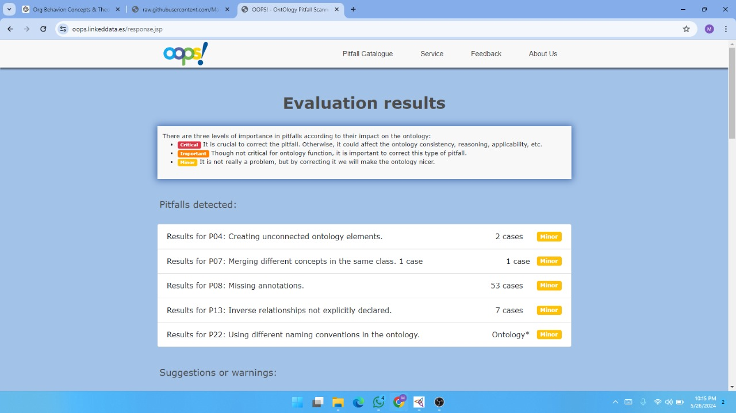

**1. Purpose and Objectives of the Ontology**

**Purpose:**

The ontology aims to facilitate the design and assessment of climate-specific building architectures by incorporating various environmental factors, building materials, and design principles.

**Objectives:**

- Enable the classification of buildings based on their climate-specific design.

- Integrate environmental factors like direction of winds, proximity to water bodies.

- Assess building materials and architectural elements for sustainability and thermal efficiency.

**2. Use Case Scenario**

Designing an Energy-Efficient Home in a Semi-Arid Climate

**Actors:**

**-Architects**: Design the building using climate-specific guidelines.

- **Building Engineers:** Assess structural and environmental aspects.

- **Software Applications:** Automate design recommendations using ontology.

**Inputs:**

- **Location:** Lahore, Pakistan.

- **Climate Data:** Semi-arid climate characteristics.

- **Design Requirements:** Energy efficiency, sustainability, thermal comfort.

**3. Example Data and Reasoning**

Populate the ontology with example data to demonstrate its practical application. For instance:

**Building Orientation:**

- Orientation: Southeast

- Roof Tilt Angle: 30 degrees

- Shading: Natural shading (trees)

**- Building Materials:**

- Material: Brick

- Material Type: Local Brick

- Thermal Properties: High thermal mass

- Sustainable Materials: True

**Environmental Factors:**

- Prevailing Winds: North-East

- Proximity to Water Bodies: 500 meters.

- Local Topography: Flat terrain

**4. Expected Outputs**

**Design Recommendations:**

- Optimal building orientation: Southeast

- Roof tilt angle: 30 degrees

- Shading methods: Use of natural shading (trees)

**Material List:**

- Sustainable building materials: Local Brick with high thermal mass

**Environmental Assessments:**

- Prevailing winds direction: North-East

- Proximity to water bodies: 500 meters

- Local topography: Flat terrain